* When adding a product manually in Products > Admin Products, to only show the sizes on the frontend that are ticked by the Admin .

For example

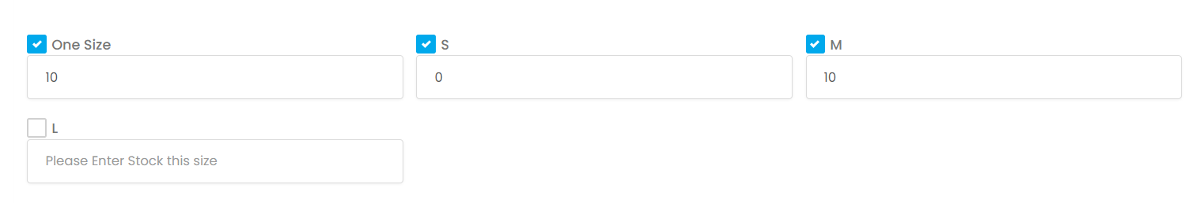

On the front end product page, the user will only be able to see sizes “One Size”, “S” and “M”.

The size “L” won’t be visible.

And because size “S” has a 0 in quantity box, it will look like this

